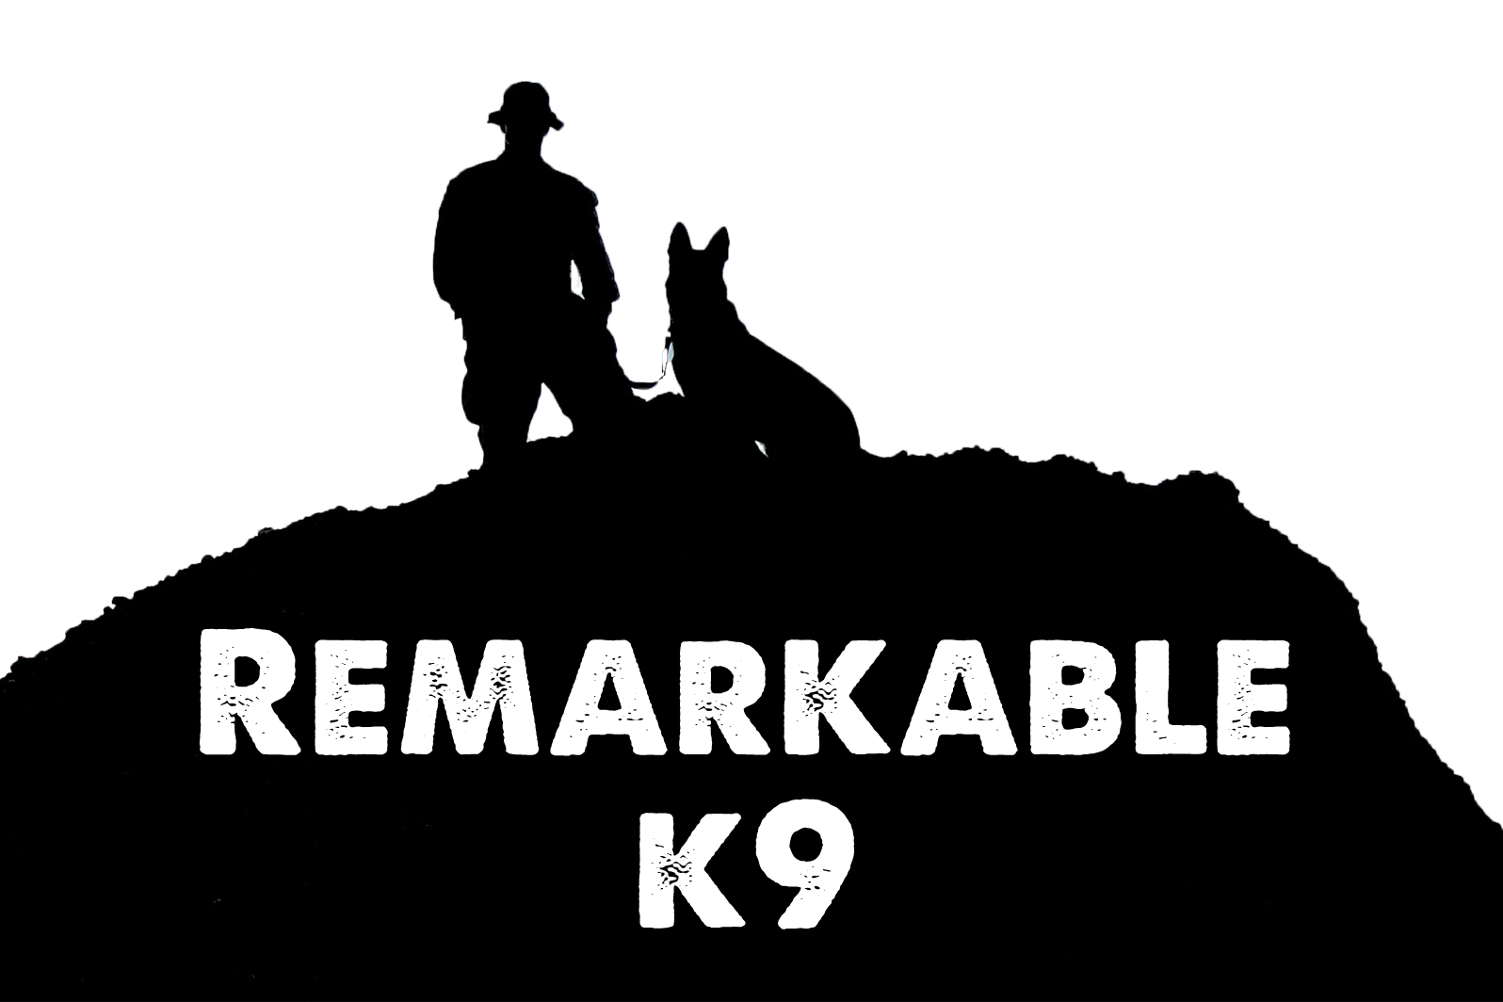

Command List

The following commands are utilized by Remarkable K9 to train their own and client’s canines. This list is not all-inclusive. Some dogs can be taught more and all dogs learn at their own pace. The dog’s ability to learn is solely on that individual canine and its drive to please. Keeping the canine trained is the responsibility of the owner(s). This can be effected by the frequency you use these commands and whomever the canine is around on a regular basis.

1. Yes - Used to ‘marker’ correct behavior and/or a release command.
2. ‘Their Name’- A dog that knows it name will look at the handler/target
3. Heel - A relaxed ‘Heel’; Dog cannot lead or pull
4. Sit - Rear end on the floor
5. Down - All four legs and stomach on the floor
6. Stay - Remain in current position
7. Come - Casual recall of dog to you
8. Take a Break/Breaks - Opportunity to eliminate waste
9. House - Go into Kennel, House, or Vehicle
10. Make Friends - Sit and be calm as public or guest greets your dog
11. Good – Marking a desired behavior
12. No – Marking an undesired behavior
13. Hup – Two front paws on a surface
14. Hup-Up – Jump onto or over object
15. Off - Jump down from raised surface (i.e. couch, crawling up legs, bed, or from the “hup” command.)
16. Leave It - Take attention away from an object or leave object or food where it is
17. Get Your Toy/Get It- Go to and pick up toy (such as when fetching, if they don’t bring it back)
18. Outside - Go outside
19. Out - Release item
20. Shh - Stop barking or other noise
21. Water - Take a drink of water
22. Easy - In a calm soothing voice while petting your dog

REMEMBER
There are three different types of voices for a dog: Praise, Command, and Correction.

Praise- A high-pitch voices which lets your canine know they are doing well
Command- A voice which is firm and stern. There should be no question you are commanding them to do something. There are NO questions in a command.
Correction- This voice lets your canine know the behavior they are offering is undesired and it needs to stop.

Remarkable K9 Solutions

