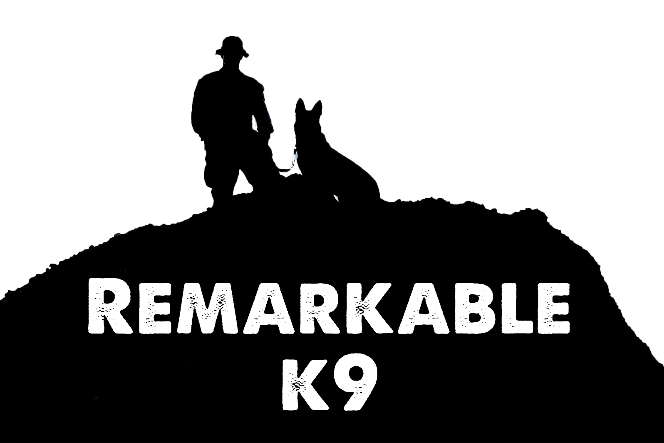

Choosing the Right Canine for You and Your Family

Dogs seek out people and take obvious pleasure in their company. They often fulfill a childlike role and are dependent in their owners for most of their life. This dependency works both ways and your dog becomes part of your family. It makes sense to try to match your lifestyle and preferences to the temperament and needs of the dog.

You may be looking for a dog with behavioral characteristics such as the ability to guard, herd, retrieve, or just sit on your lap. Other questions you will need to ask yourself are what age? size? sex? pure breed or not. For most pet parents, the age is considered first.

What age of dog? Of course, a puppy is delightful, especially if you have got children in the house, but there may be reasons why an older dog is better. If you are looking for a good companion right from the start, a young adult dog may be best. A puppy requires someone around all day to properly house train and to develop a good relationship. If you choose an older dog, make sure it is house-trained, a dog that has been kenneled for a long time may not be.

Size is the next important consideration. Large breeds are both expensive to buy and to feed, they need a lot of space and a lot of exercise and are not well suited to city living in an apartment. Small and toy breeds need far less space and exercise, they eat less too! But you must take care with young children, as toy breeds bones are fine and fragile and children can accidentally hurt them seriously. Large breeds also age quicker than the smaller breeds and most do not live beyond 14 years, while the smaller breeds can live to be 20 years old.

Male or female is the next consideration, and most owners have their own preferences. Females are usually more demanding of attention, but they are easier to train and develop a more solid attachment to their owners. Male dogs are usually more consistent in their temperament, but are more difficult to train due to their independent nature. Male’s may become so aggressive or wander so much that neutering is called for. This is not always successful and can change the dog’s character.

Pedigree or not? Non-pedigree dogs sometimes called mongrels, have a lot in their favor. While they are not as predictable in terms of looks and temperament, they are much less afflicted by inherited diseases than pedigree dogs and seem to avoid some of the more common ailments. Pedigree dogs can develop ailments that are common to their breed that gets passed to each new generation. You should look into the hereditary defects of any pedigree you are considering. Most of these ailments do not occur until the animal is old, but they will occur.

No matter what type, breed, age, size, color, or other choice of dog you make, just remember, they will all need part of your time and space. Owning a pet and becoming a good pet parent is a commitment, but it can be one of the best and happiest commitments you can make, for both of you.

Remarkable K9 Solutions

